**Web Services**

Web Service allows to communicate programs running on different operating systems and written in different languages via internet standards XML and HTTP.

In this document, we’ll be creating ‘*Service Consumer’* by consuming a WSDL file provided by TIBCO. To create a Web Service in SAP we need a WSDL file (an XML file provided by TIBCO). We will push some data to Tibco and in response we’ll get some messages. Development related to Web Service can be divided in three parts:

1. Create Service Consumer
2. SOAMANAGER Configuration
3. Use of Proxy Class in Program

**Create Consumer Proxy:**

**Step 1:** GoTo TCode: SE80 🡪 Enter the Package Name 🡪 Right Click on Package Name 🡪 Create 🡪 Enterprise Service 🡪 You’ll get below screen:

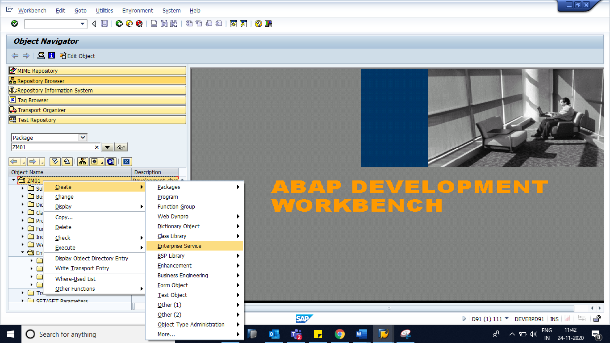

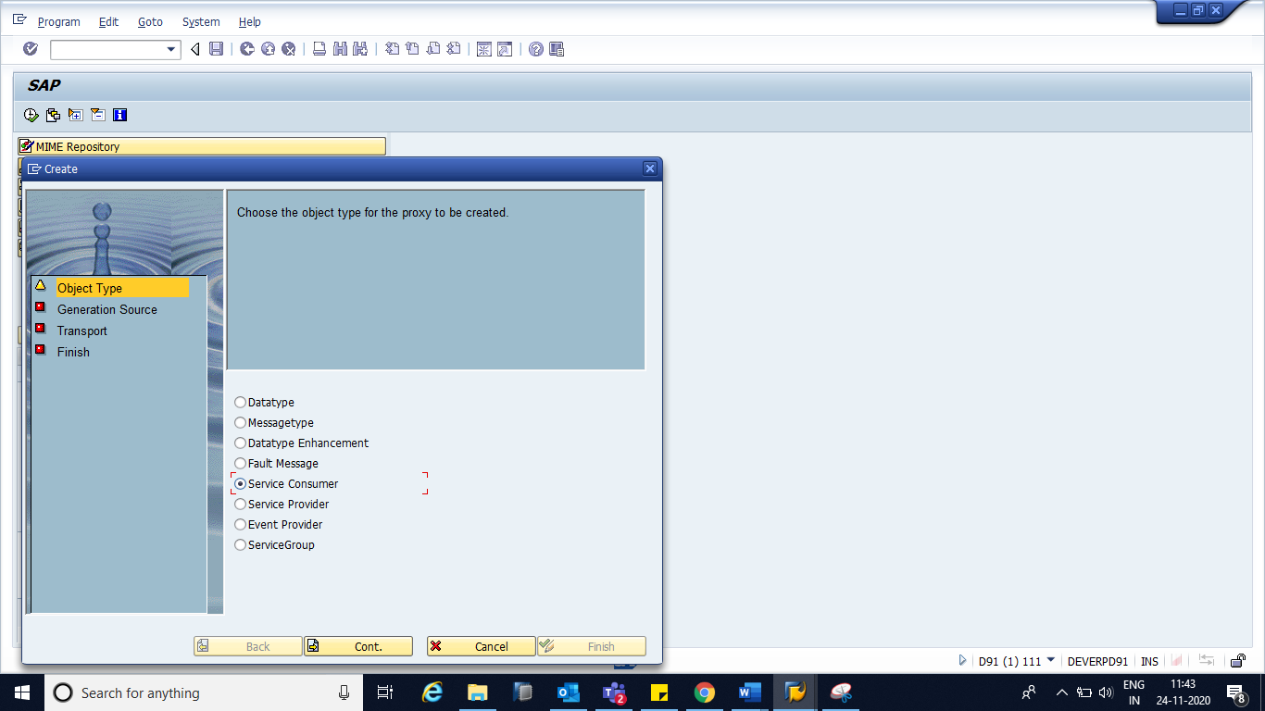

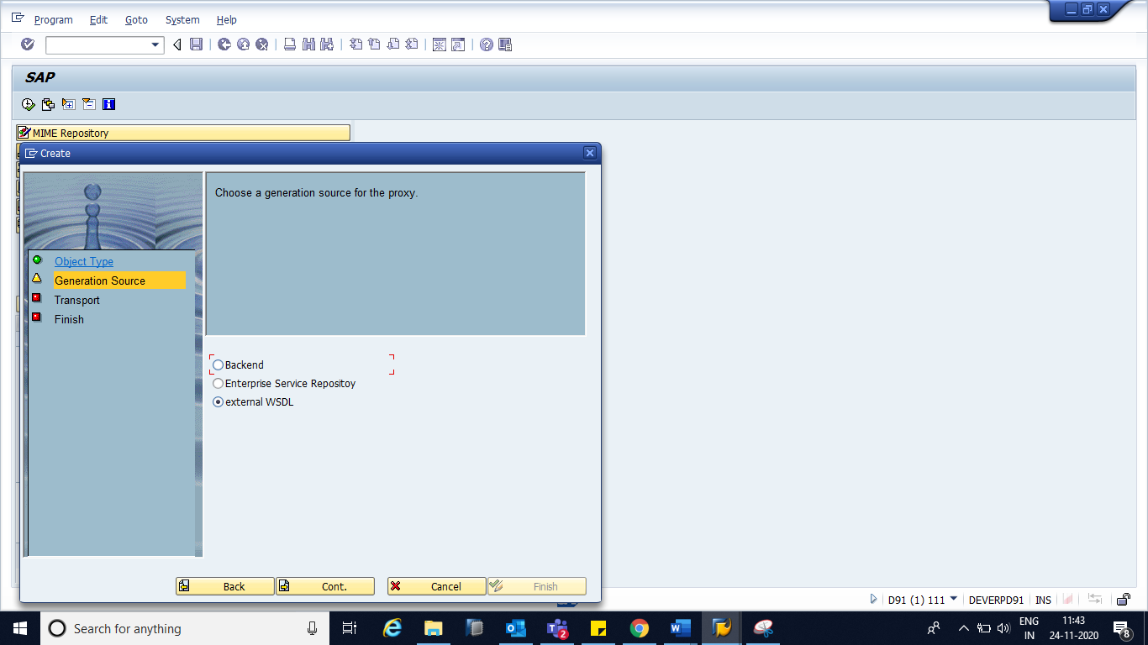

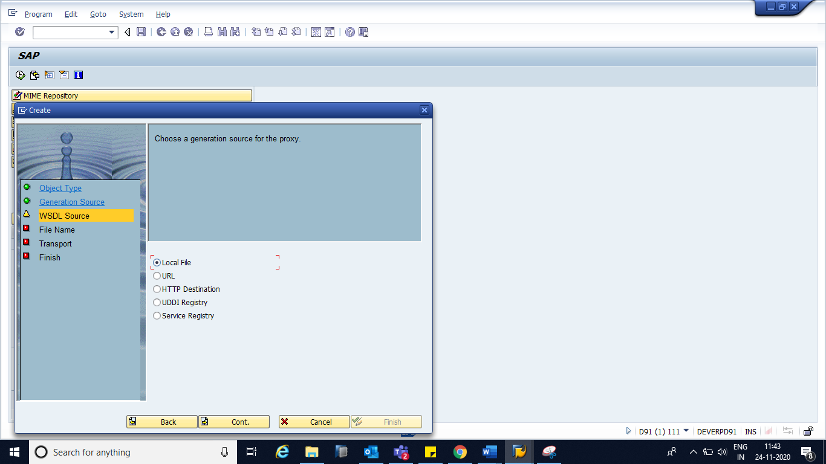

*Order of content element in WSDL should be maintained in following order:*

1. *Types*
2. *Message*
3. *PortType*
4. *Binding*
5. *Service*

If contents are not in correct order as mentioned above, we’ll get error at the time of uploading WSDL file.

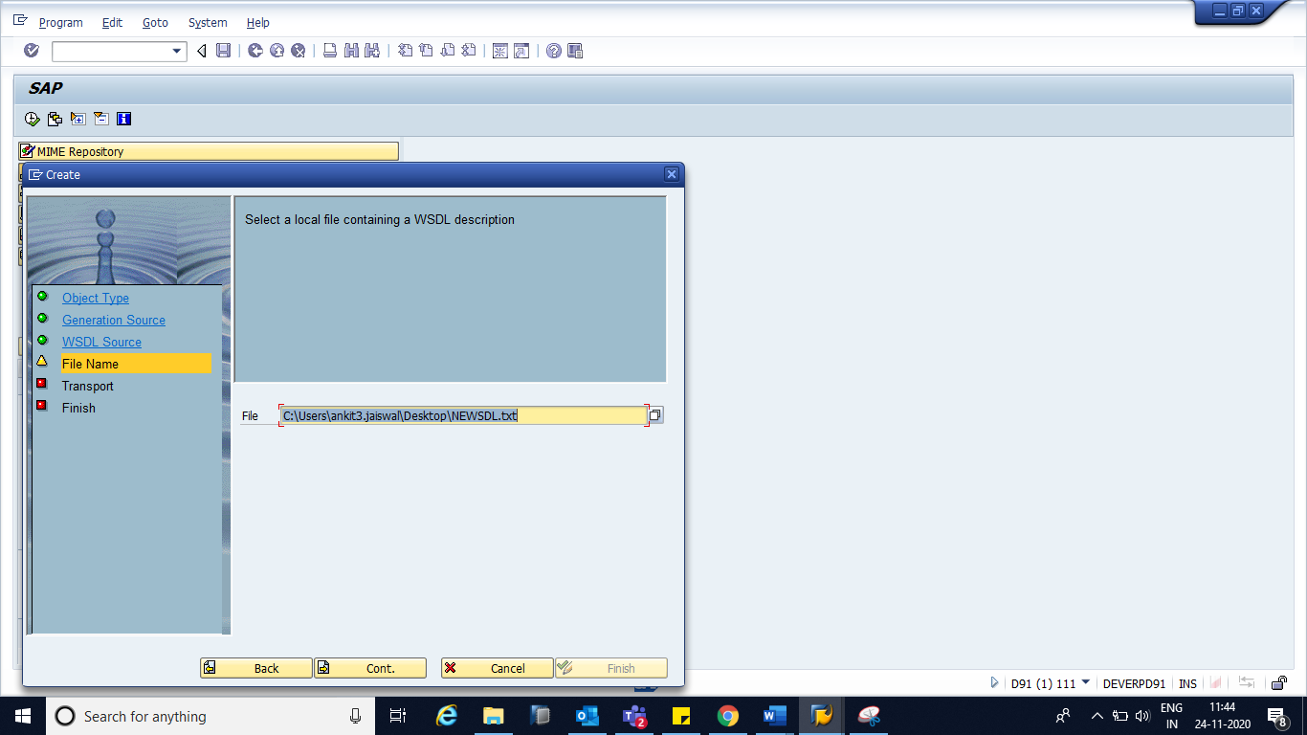

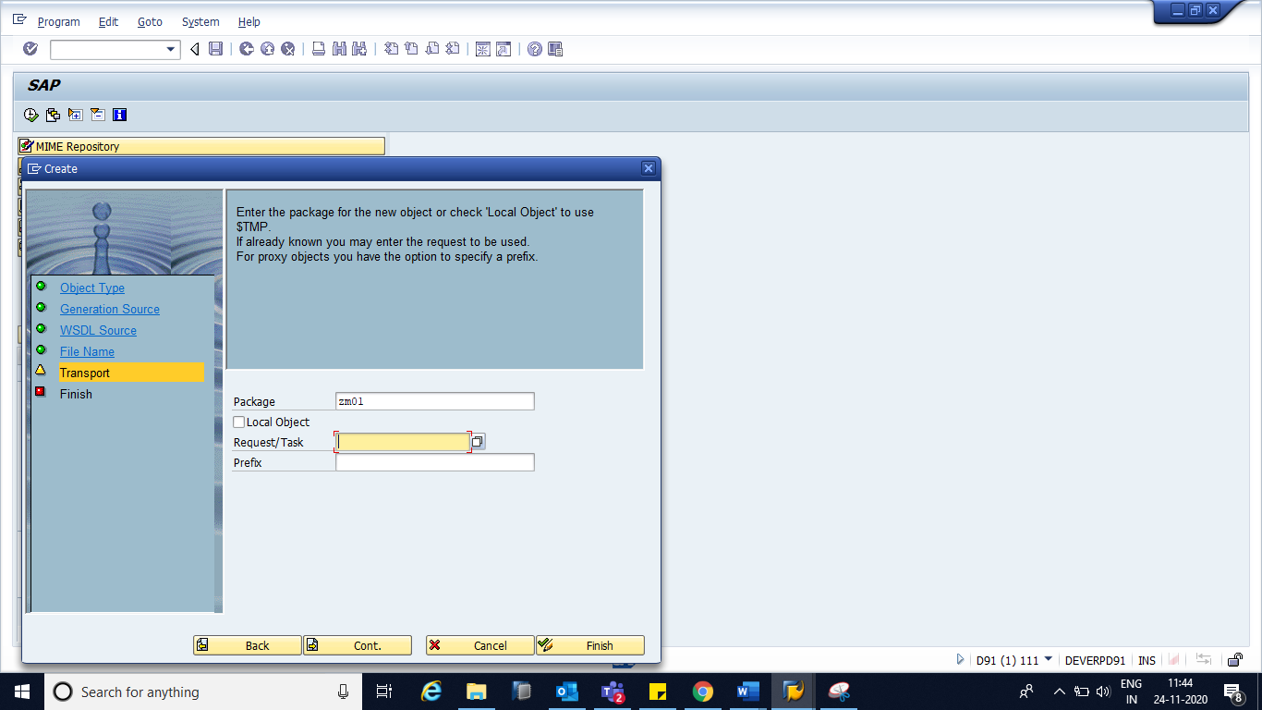

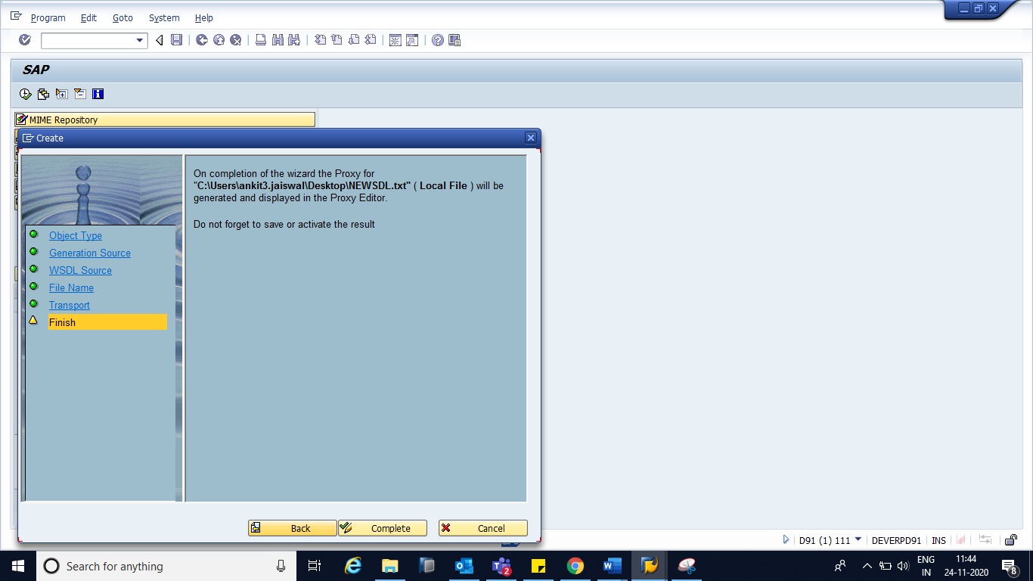

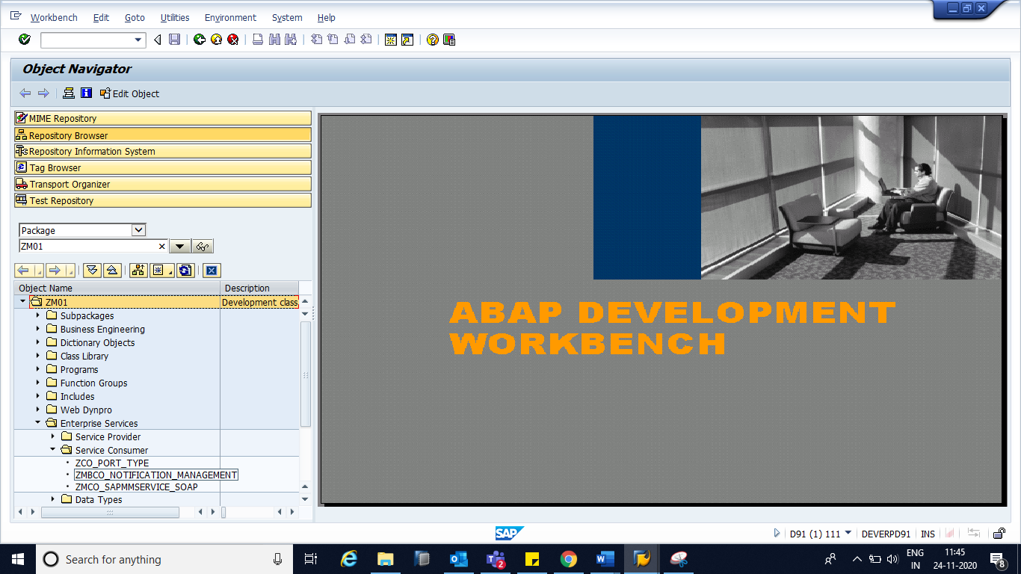

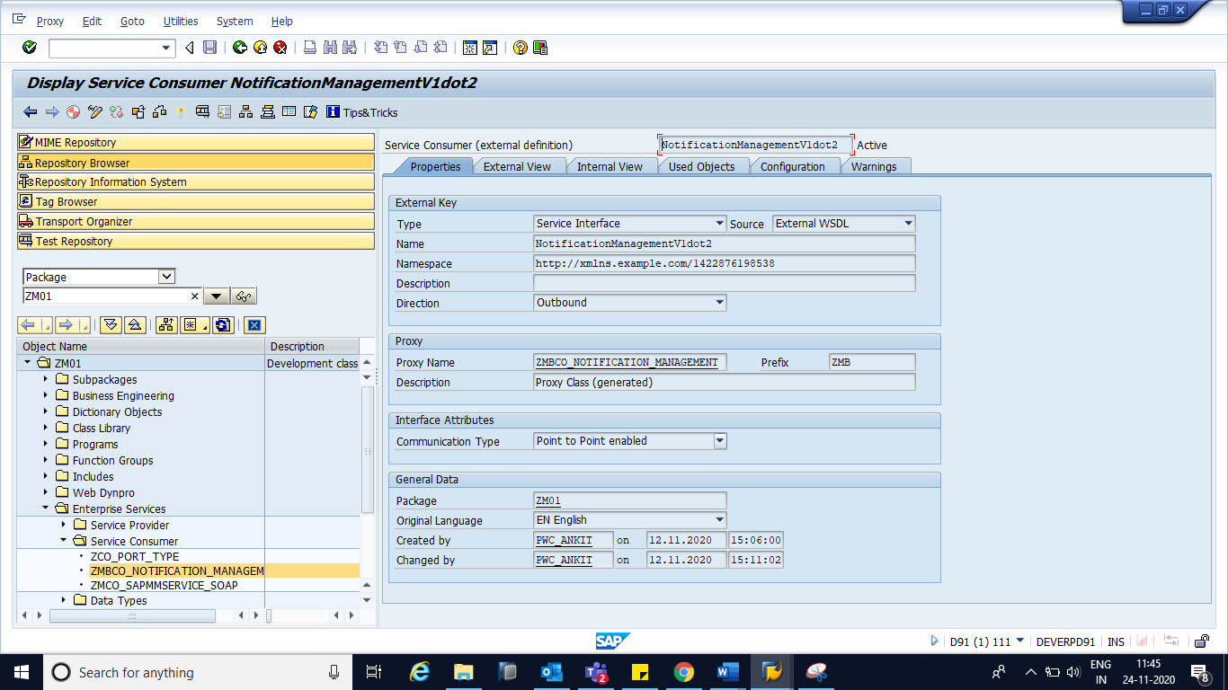

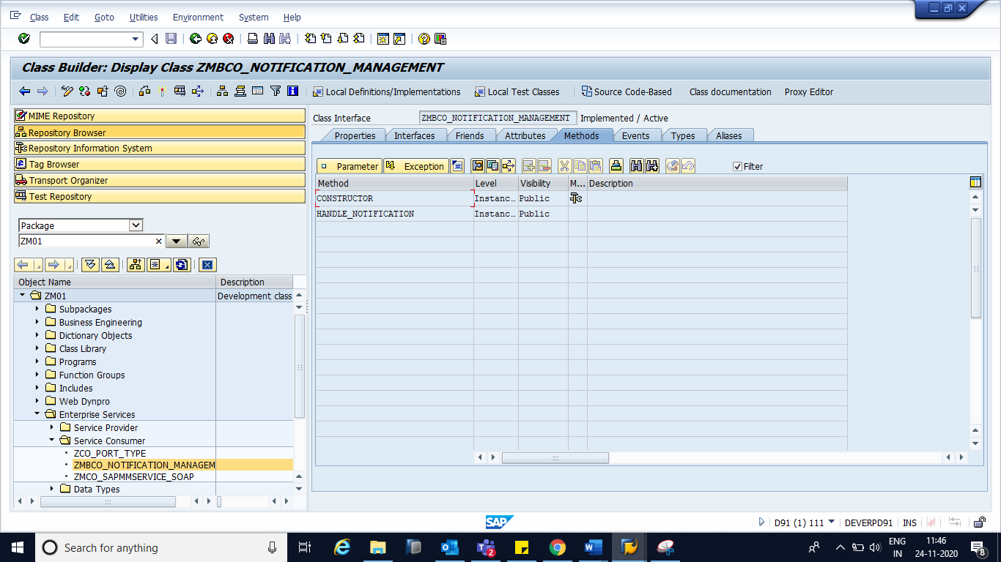

Input Parameter will take Input from SAP and if it pass the data to TIBCO, we’ll get the result in Output Parameter.

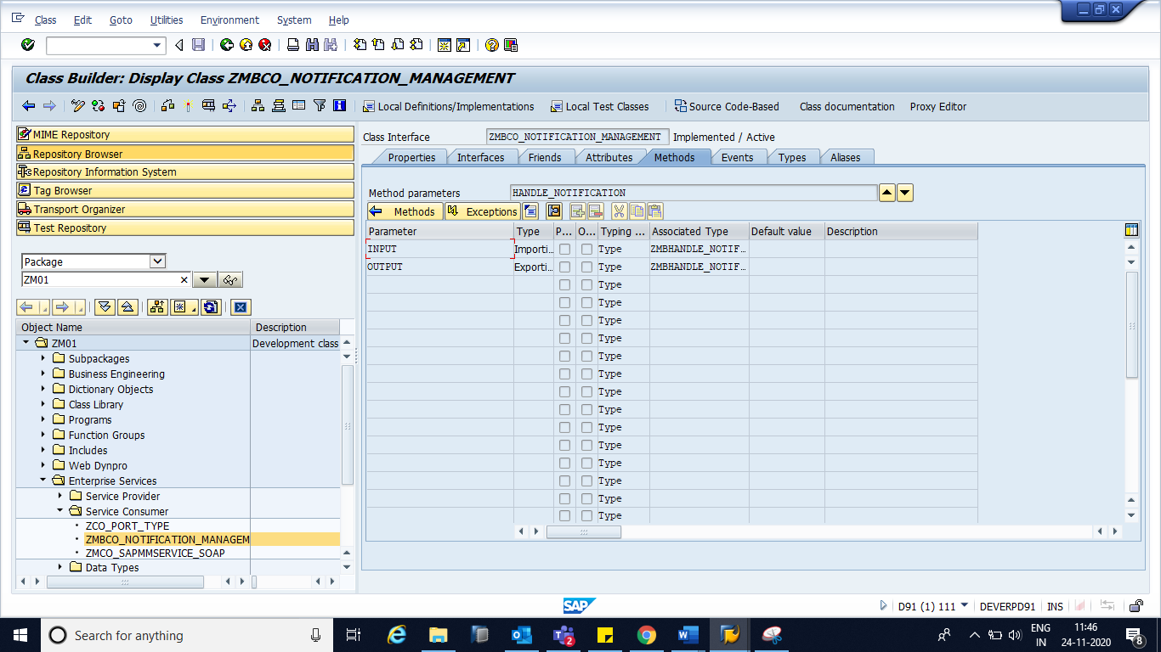

Navigate to Tab ‘External View’ 🡪 Fault 🡪 ZMBCO_NOTIFICATION_MANAGEMENT is the generated Exception Class

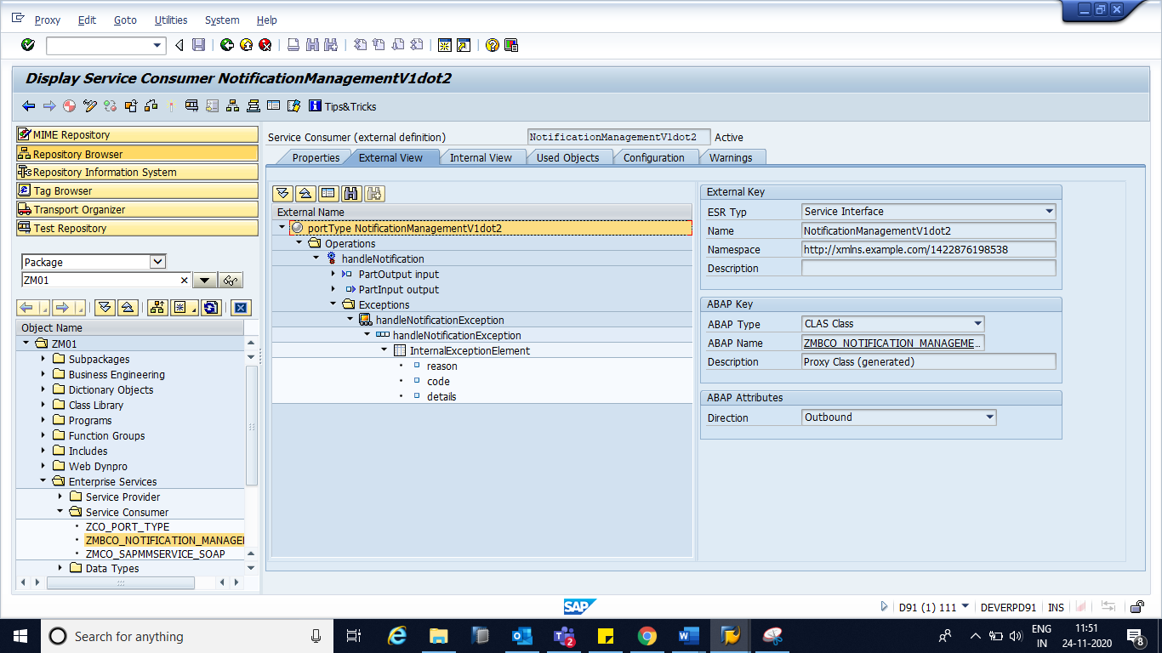

Navigate to ‘Objects’ tab to check the generated objects (Proxy Class, Exception Class & Structures)

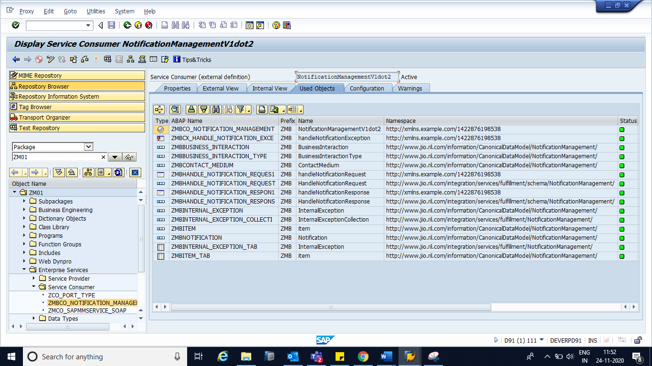

Service Consumer Creation Part is over

**Now this Web Service should be configured in SOAMANAGER to publish it.**

***SOAMANAGER*** *Configuration should be done in Test Client.*

**Step 1:** GoTo TCode SOAMANAGER 🡪 it’ll be open in Internet Explorer 🡪 Below screen will appear 🡪 Click on Web Service Configuration

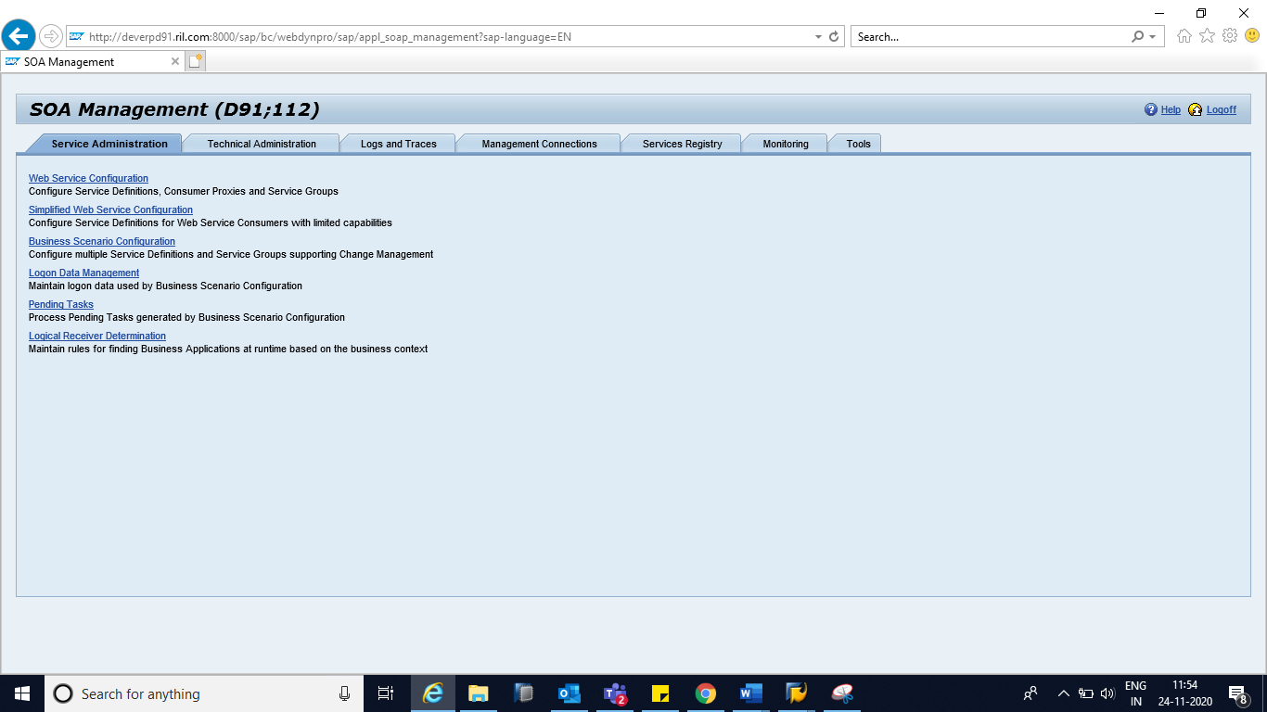.

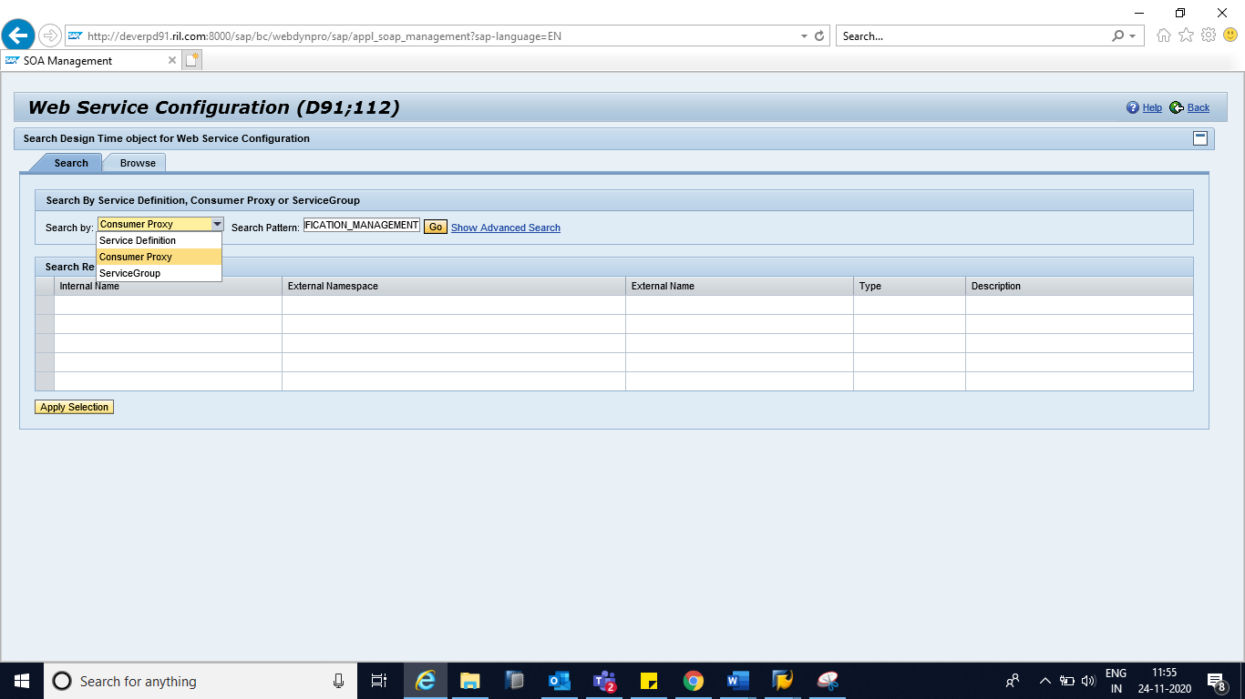

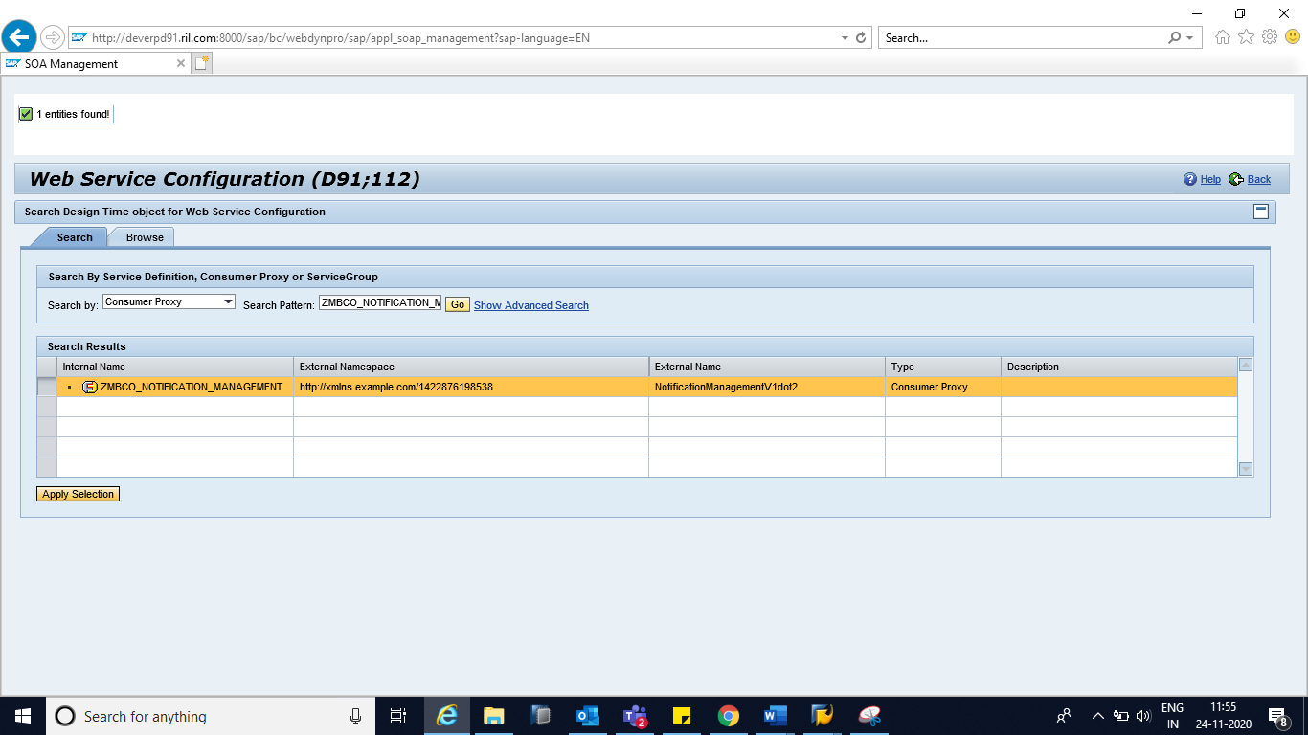

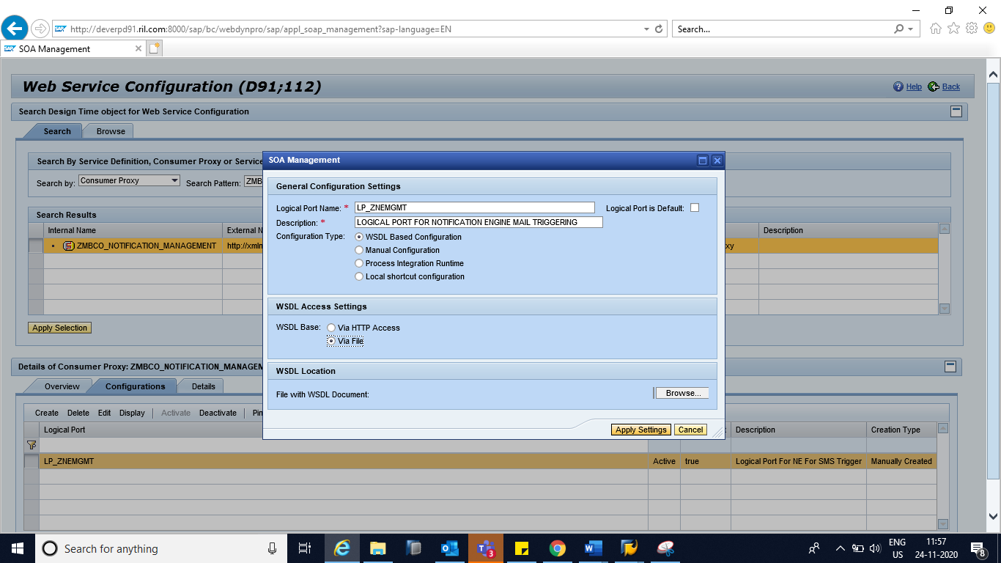

Computer Name of Access URL and Port Number of Access URL will be provided by TIBCO.

Computer Name of Access URL: 10.144.114.114

Port Number of Access URL: 30905

To check this URL, we need to ask Basis if Telnet is happening to this IP and Port Number from our SAP server.

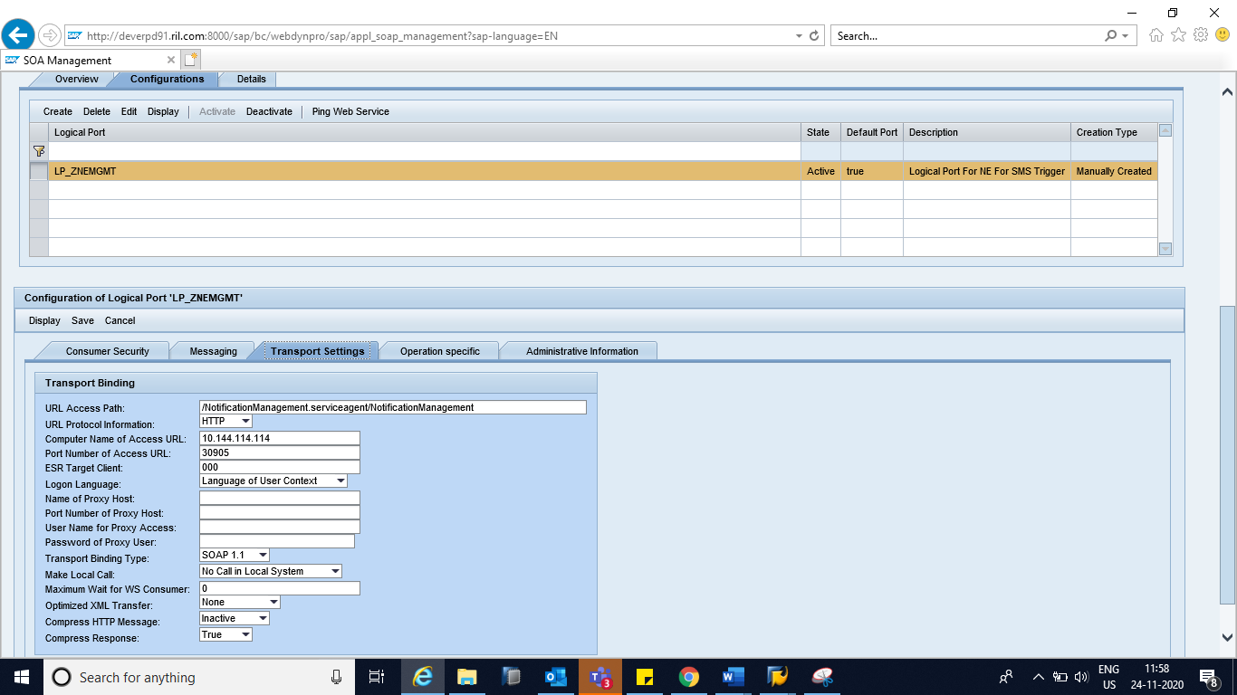

SAVE it Now SOAMANAGER Configuration is over.

**Using Proxy Class in Program**

**Step 1:** Create Object for the Generated Proxy Class: zmbco_notification_management.

TRY.  
      CREATE OBJECT lr_obj.  
*\*    EXPORTING*  
*\*      logical_port_name  = 'LP'.*  
    CATCH cx_ai_system_fault INTO lr_exception.  
      ev_message = lr_exception->get_text( ).  
      RETURN.  
  ENDTRY.  
  
**Step 2:** Call the Method ‘handle_notification of Proxy Class: zmbco_notification_management

TRY.  
      CALL METHOD lr_obj->handle_notification  
        EXPORTING  
          input  = ls_input  
        IMPORTING  
          output = ls_output.  
    CATCH cx_ai_system_fault INTO lr_exception.  
      ev_message = lr_exception->get_text( ).  
      RETURN.  
  
  ENDTRY.

*Please check the Test FM: Z_SEND_NOTIFICATION In D91 server .*

**Troubleshooting**

1. File contents should be in correct order:

Types

Message

PortType

Binding

Service

1. If TIBCO is not getting hit from Web Service, then get the IP and PORT from SOAMANAGER and check with Basis if Telnet is happening.
2. SOAP Action name should be same in SOAMANAGER and TIBCO. If TIBCO is not getting hit then check SOAP Action in both the system (SAP & TIBCO).

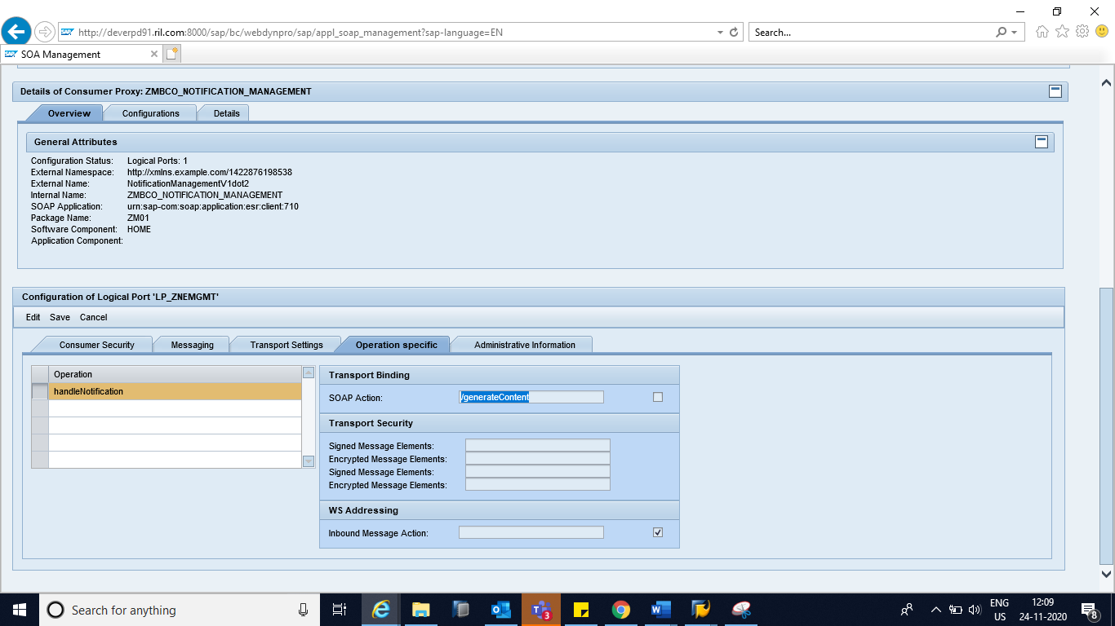

1. Web Service can be traced by using Web Service Utilities (TCode: SRT_UTIL)

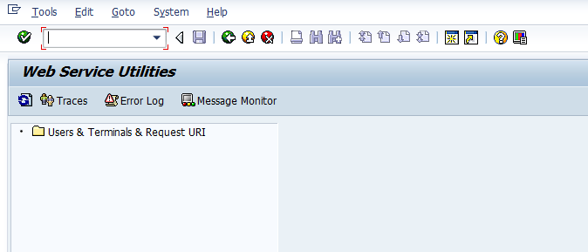

Click on Add user or Terminal

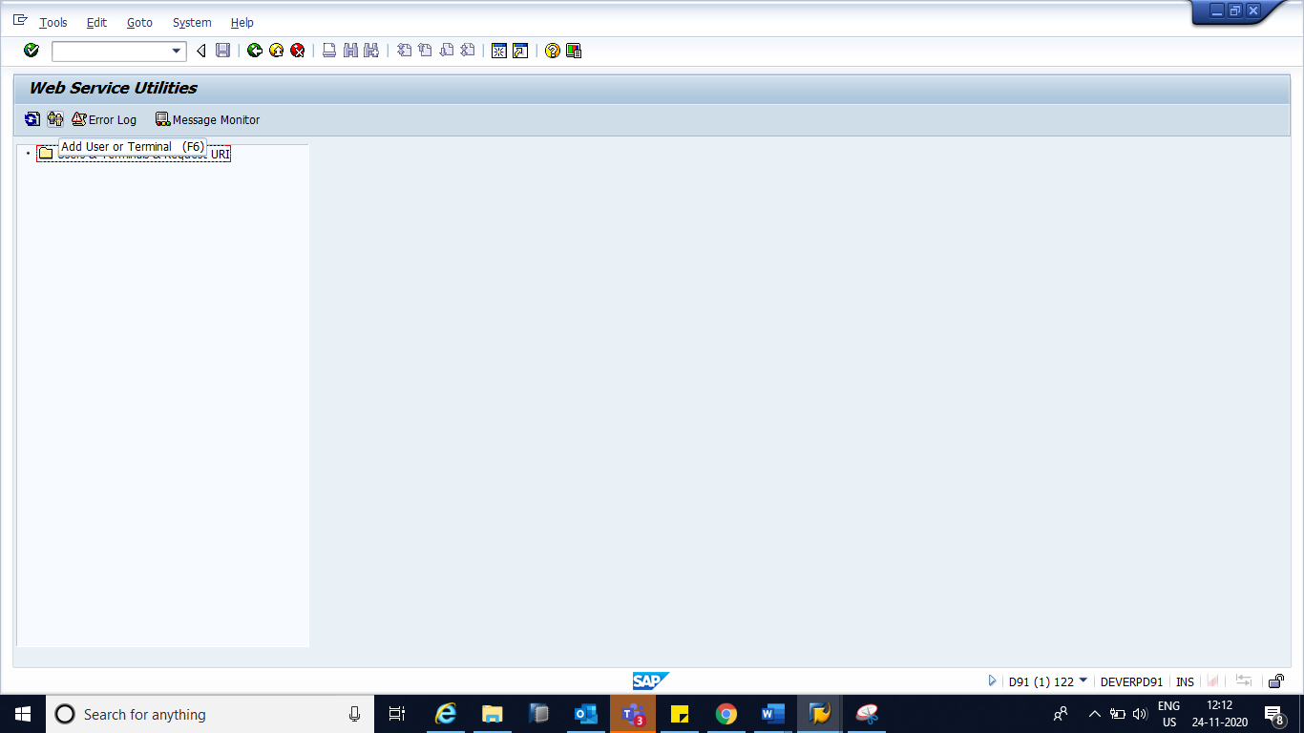

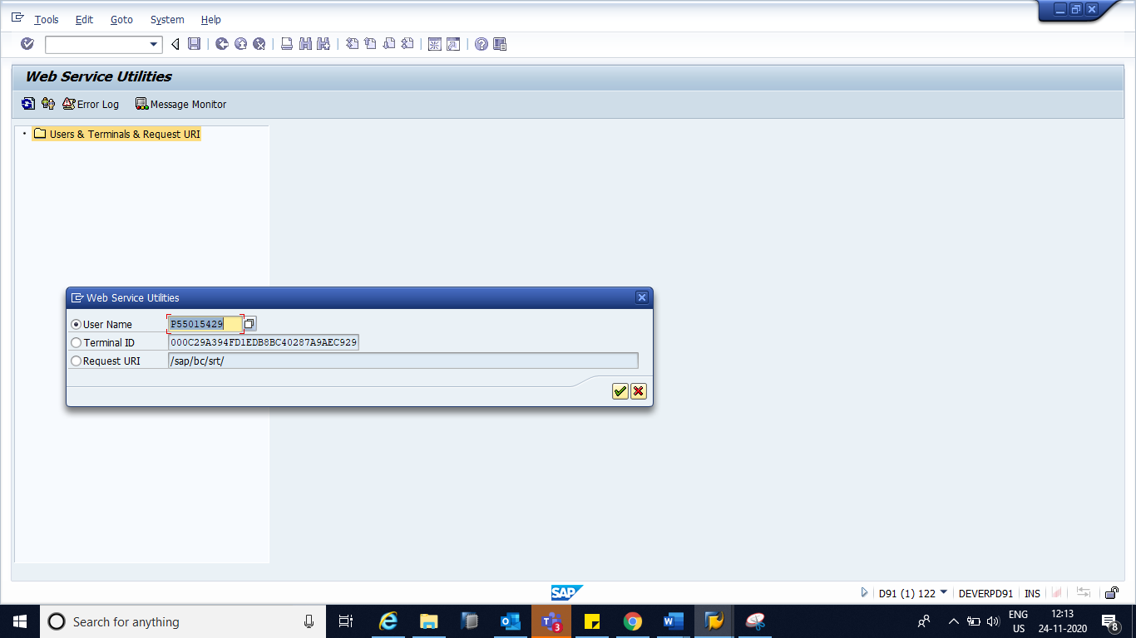

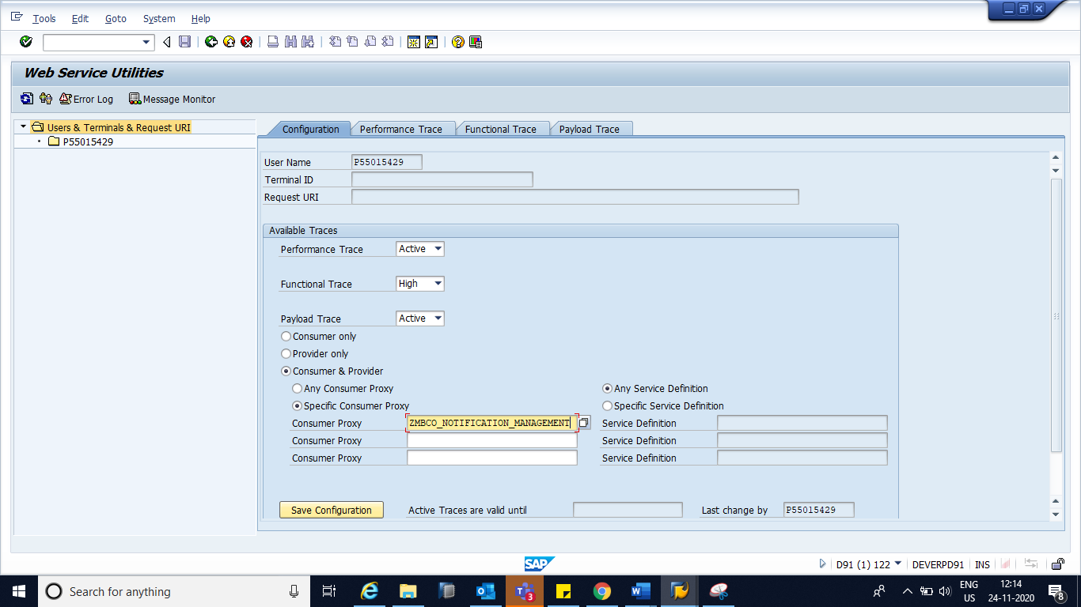

Execute the Program which is calling Web Service 🡪 In case of any issue, it can be traced by Clicking on ‘*Error Log’* button.